Veeam Backup server revert to New VM creation

Open RDP : 10.0.1.130

Step 1 :

Veeam Backup & Replication Console

Home 🡪 Backups🡪 Disk

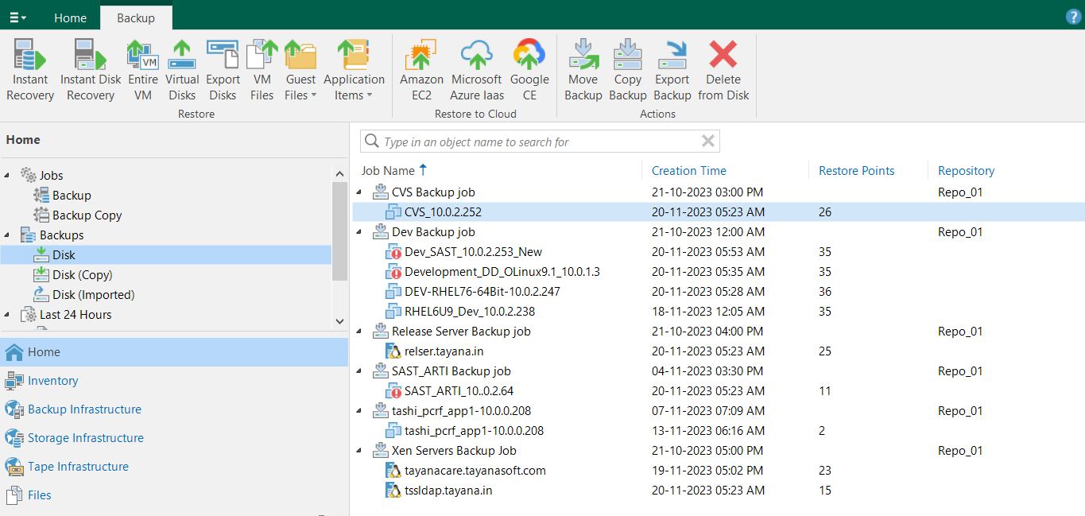

Select the Job File eg : CVS Backup Job ( CVS 10.0.2.252) Select

Select the JOB File eg : CVS 10.0.2.252 Right Click 🡪 Restore Entire VM.

Right click for Entire VM and it will pop up the window

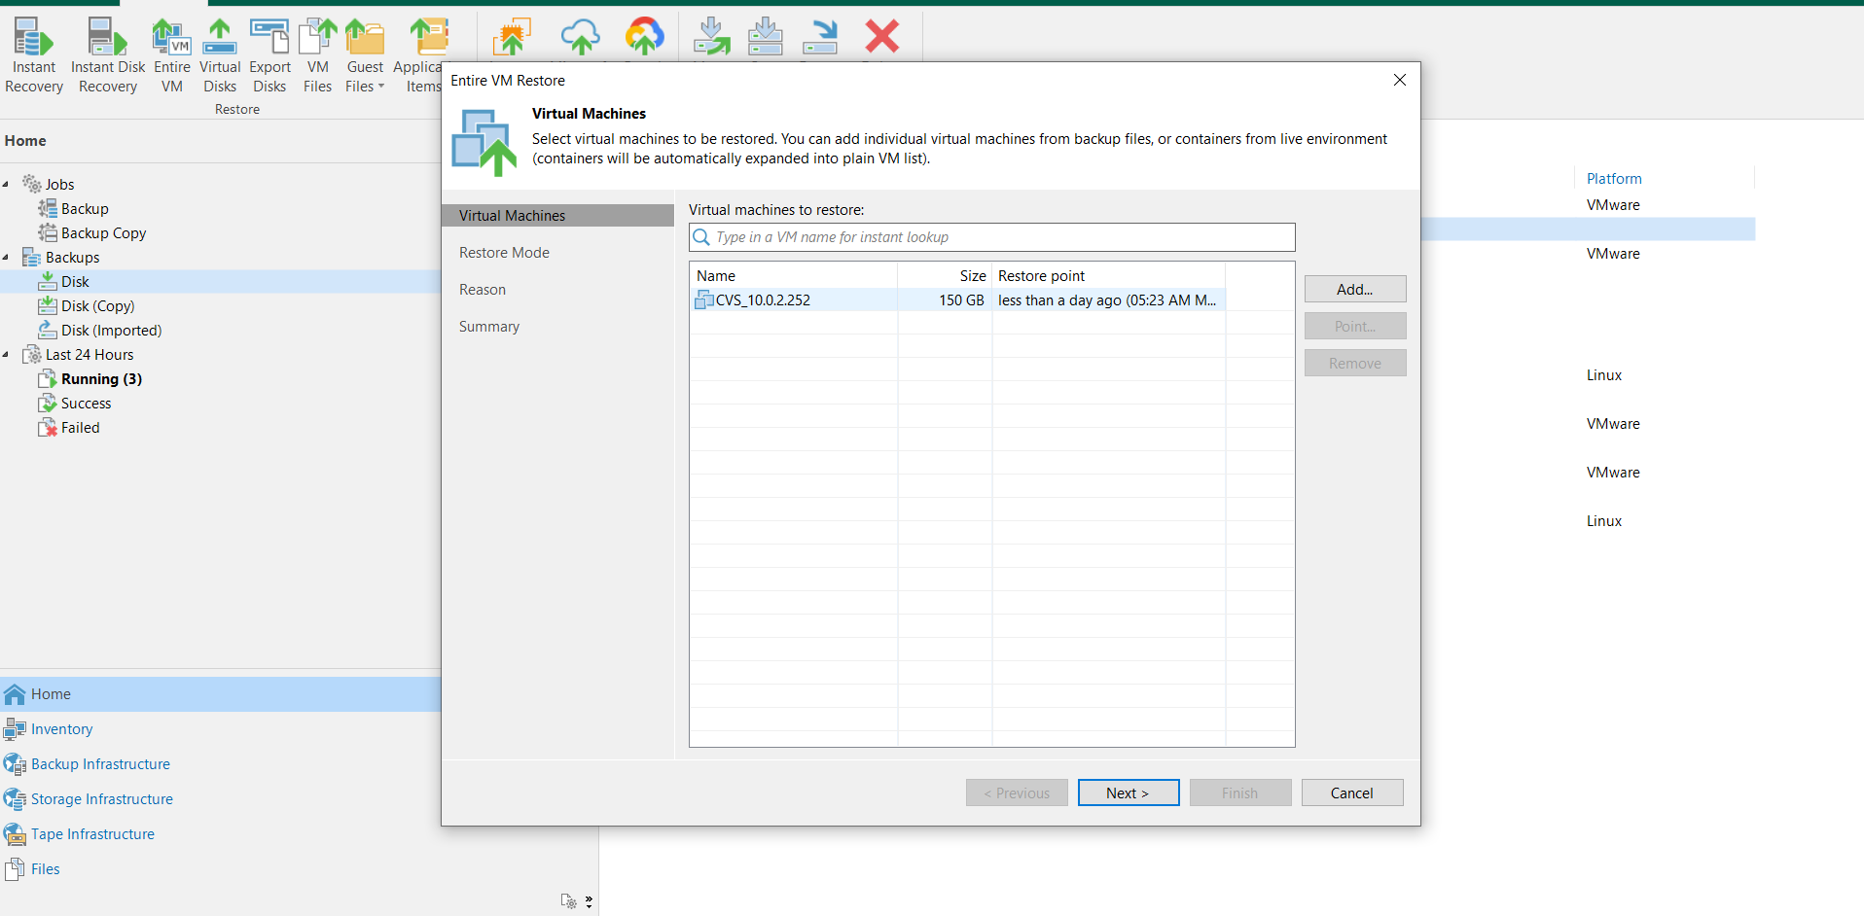

Select the VM 🡪 Next

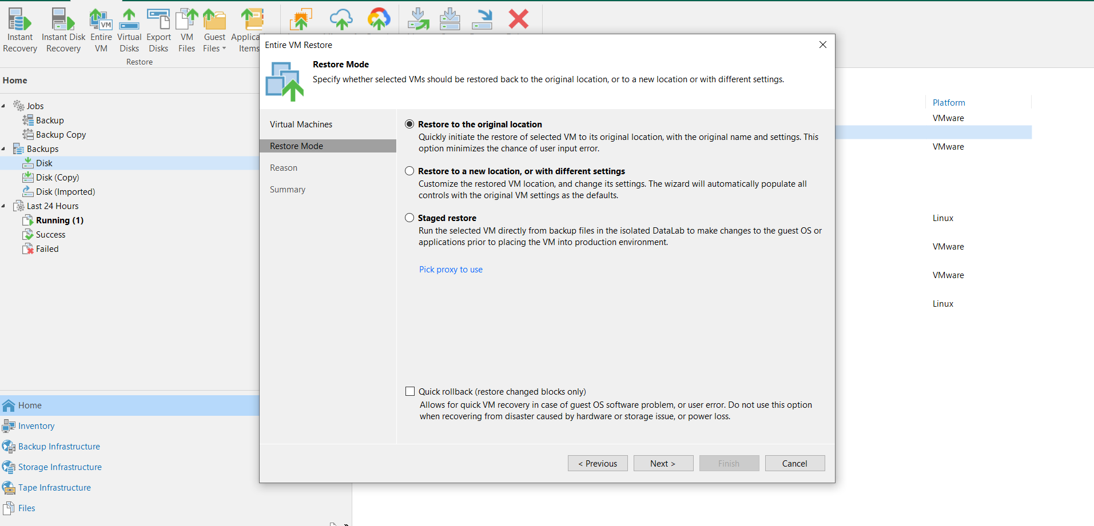

Restore a original Location If needed.

But we are moving new locations

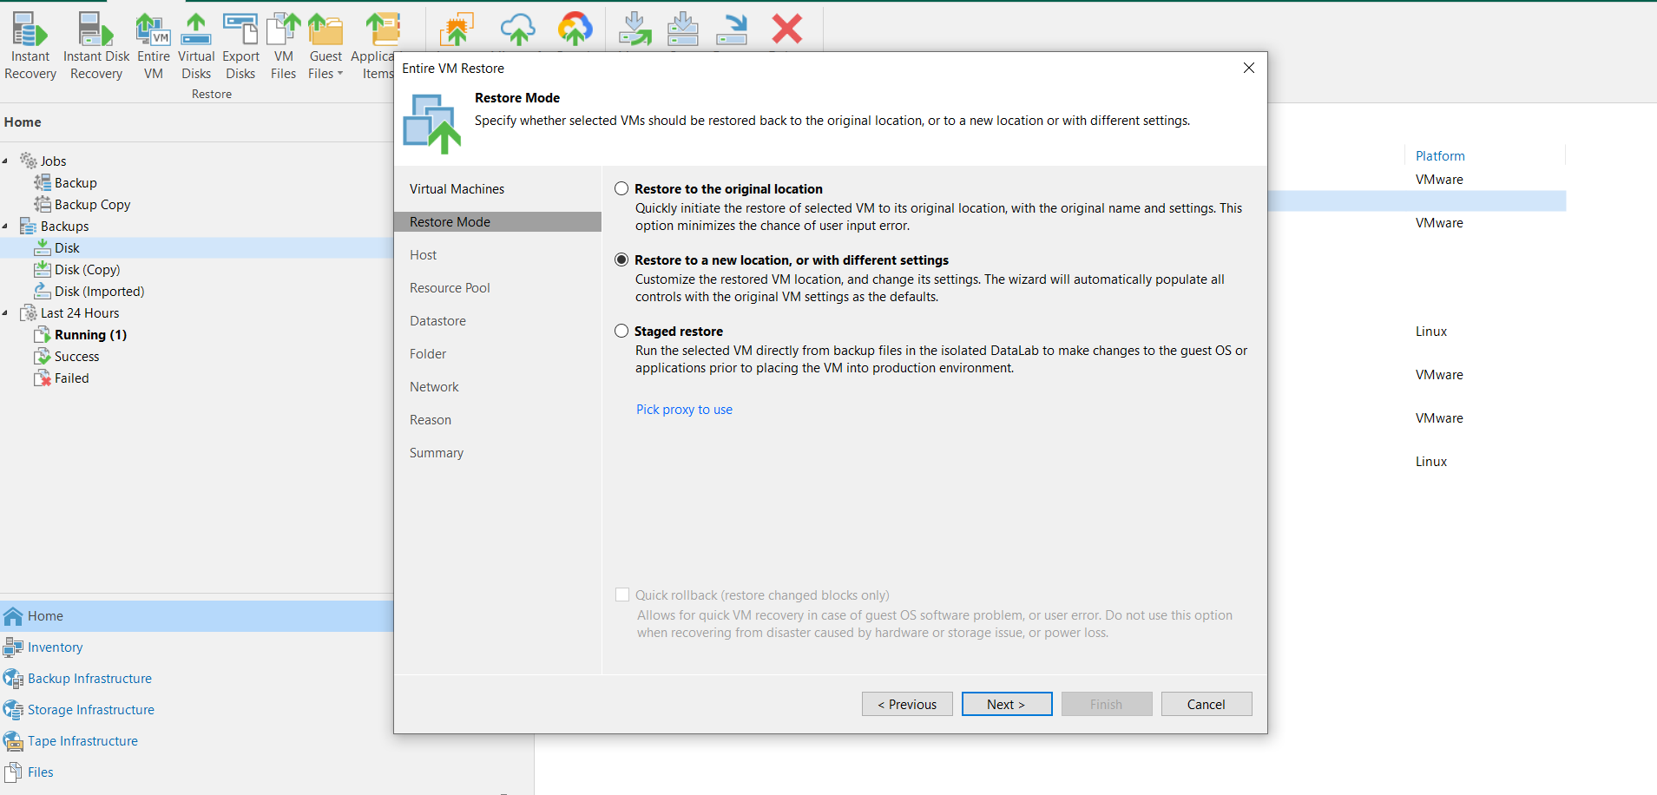

Select 🡪 Next



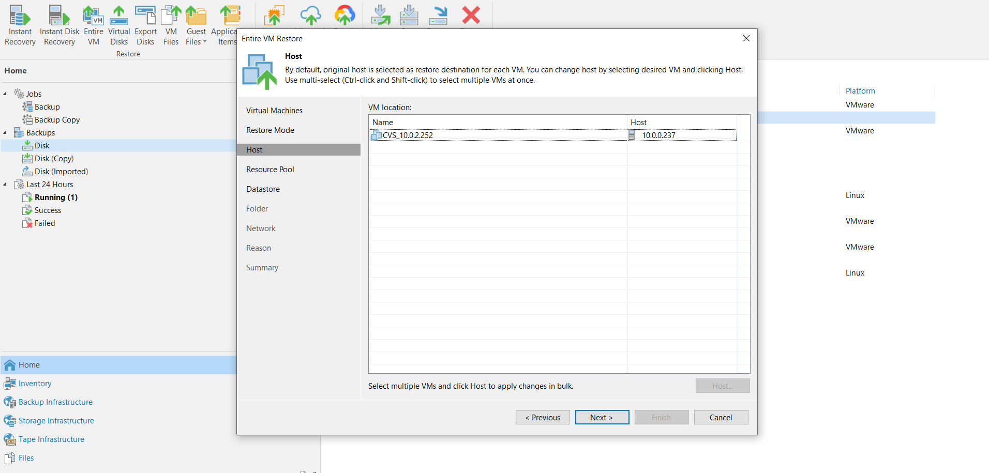

VM location, Need to change the HOST if required : Select the VM and Click the **HOST**

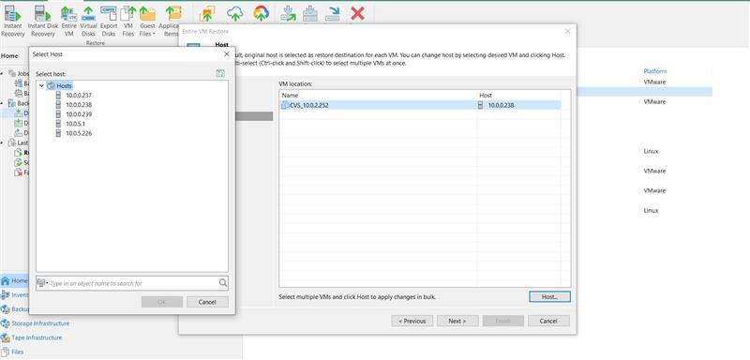

Select the which HOST you need to install this VM backup eg : 10.0.0.238 🡪 Ok

Select 🡪 Next

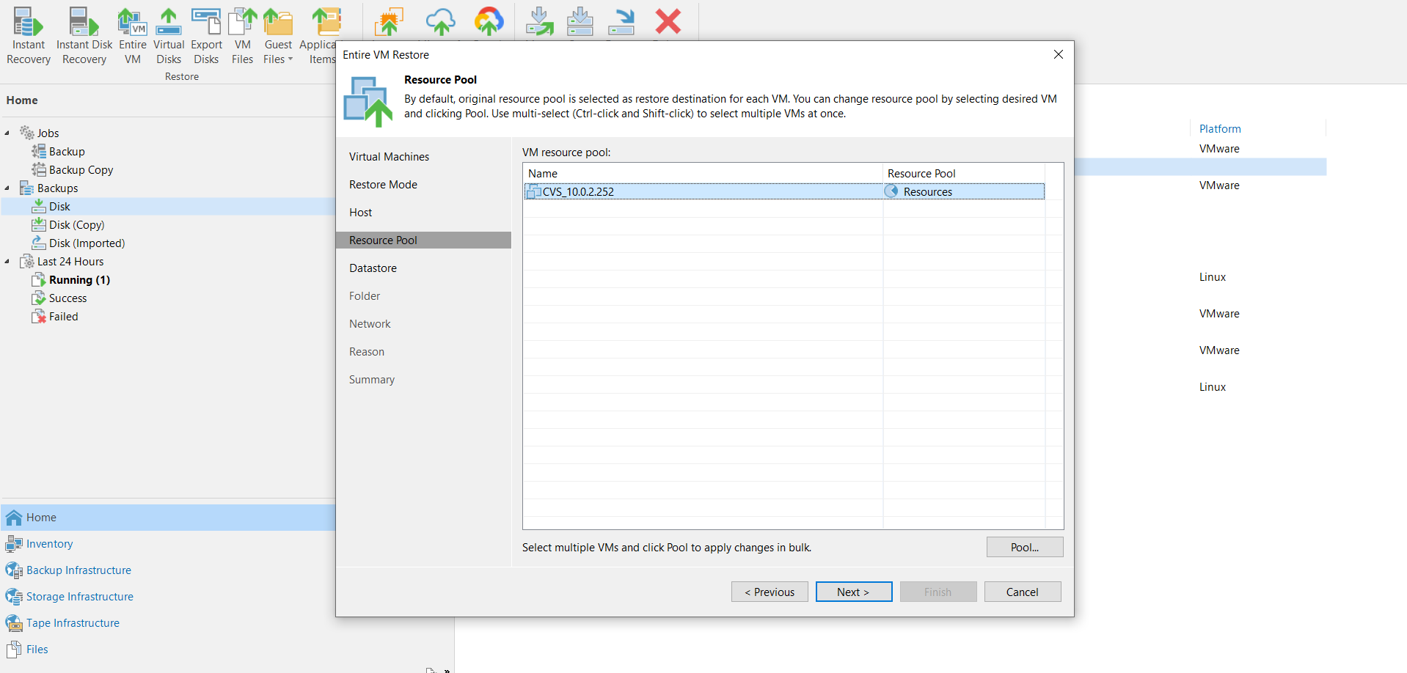

Select 🡪 Next

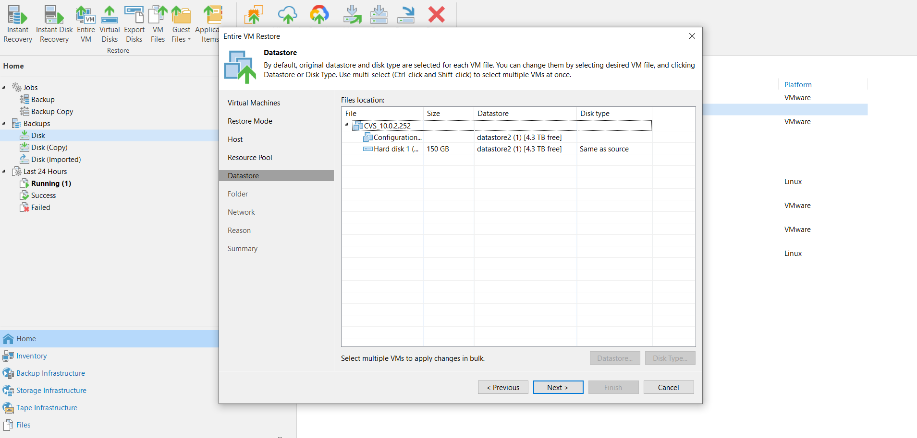

Select 🡪 Next

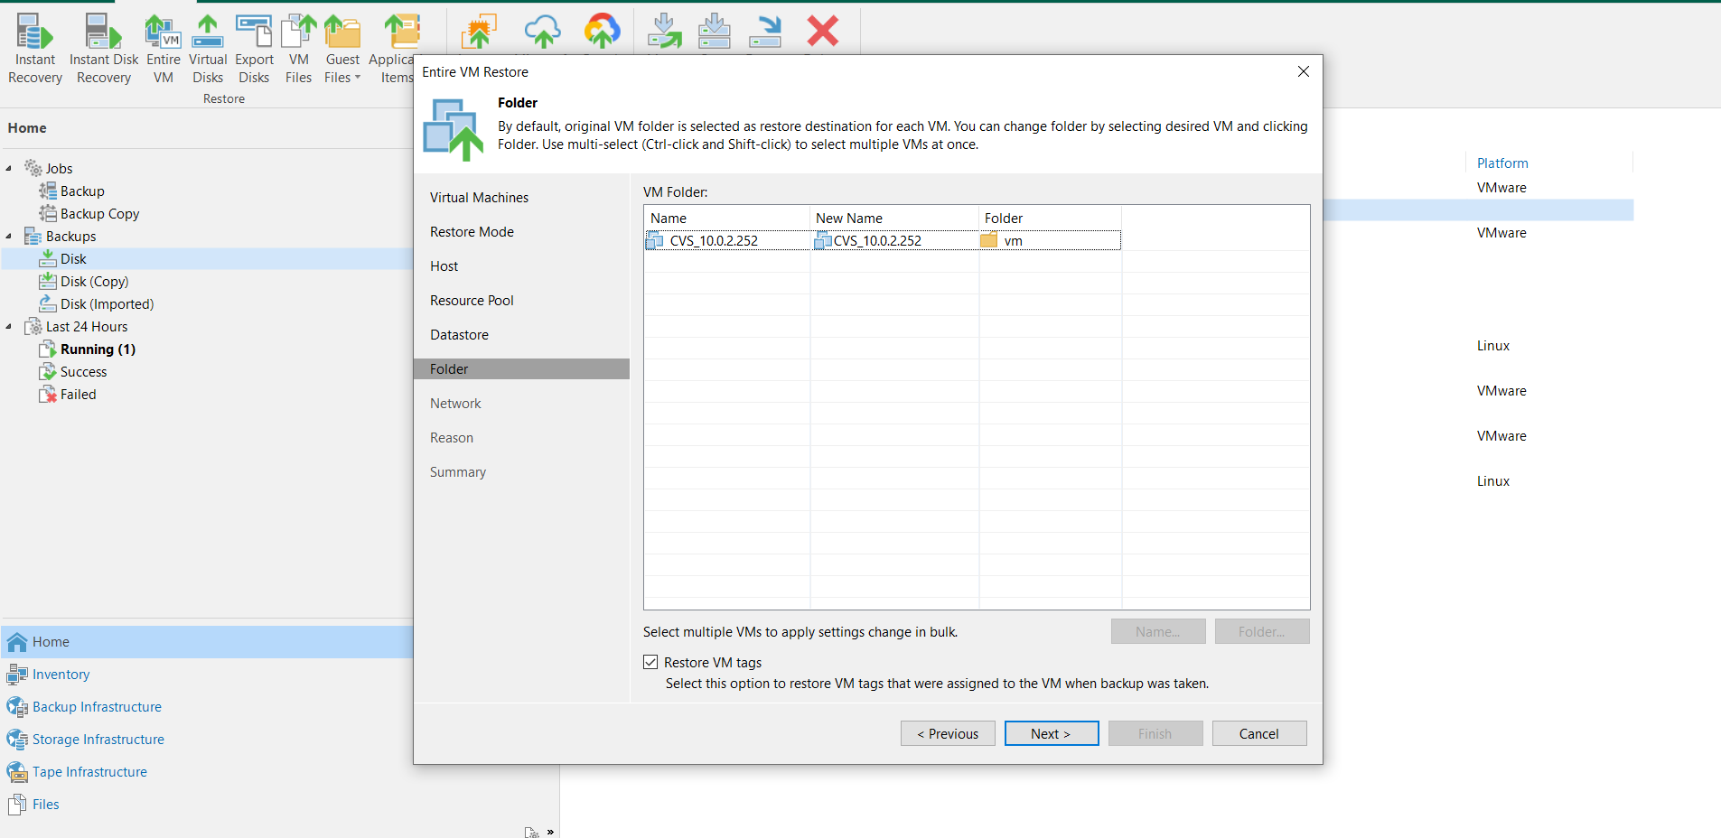

Need to change VM name from old name to New Name,

Select the VM and Click 🡪 Name

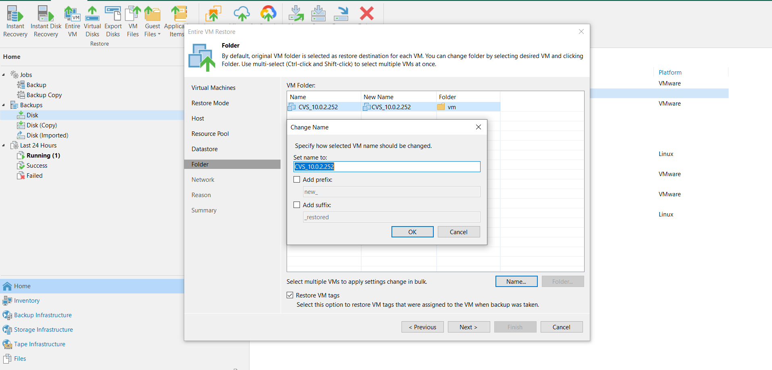

Change the name from CVS_10.0.2.252 to Restore_20/11/2023_CVS_10.0.1.245

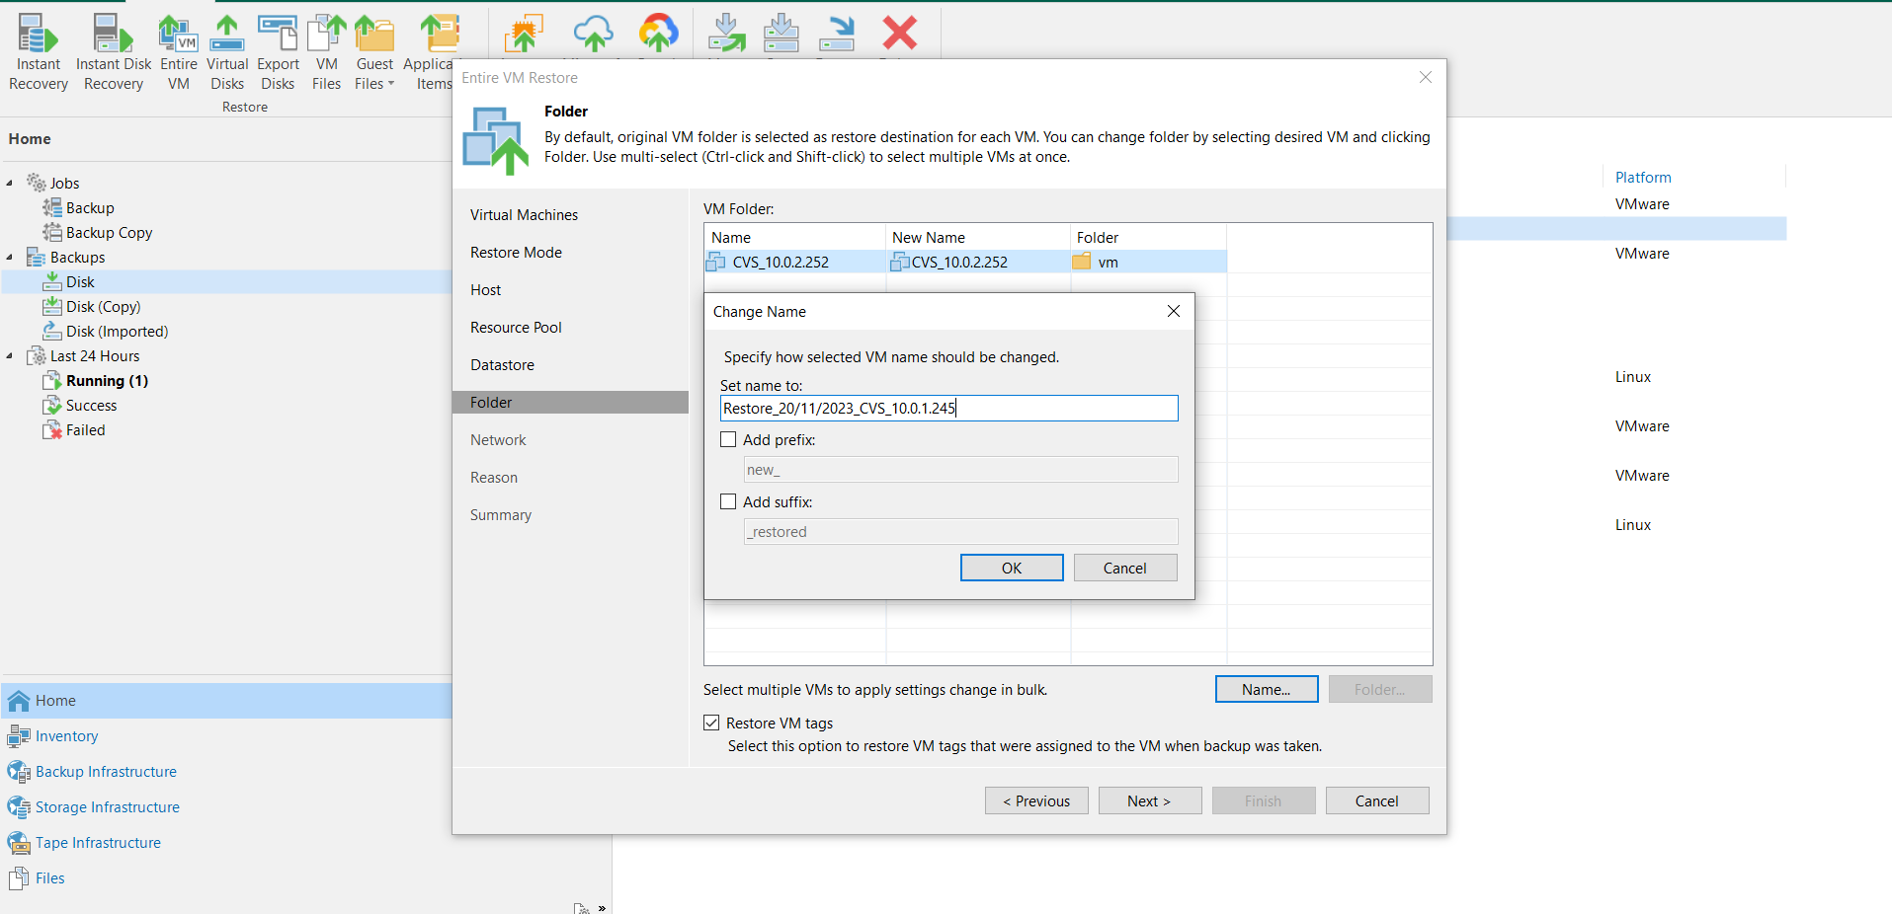

Once changed the name Select 🡪 OK

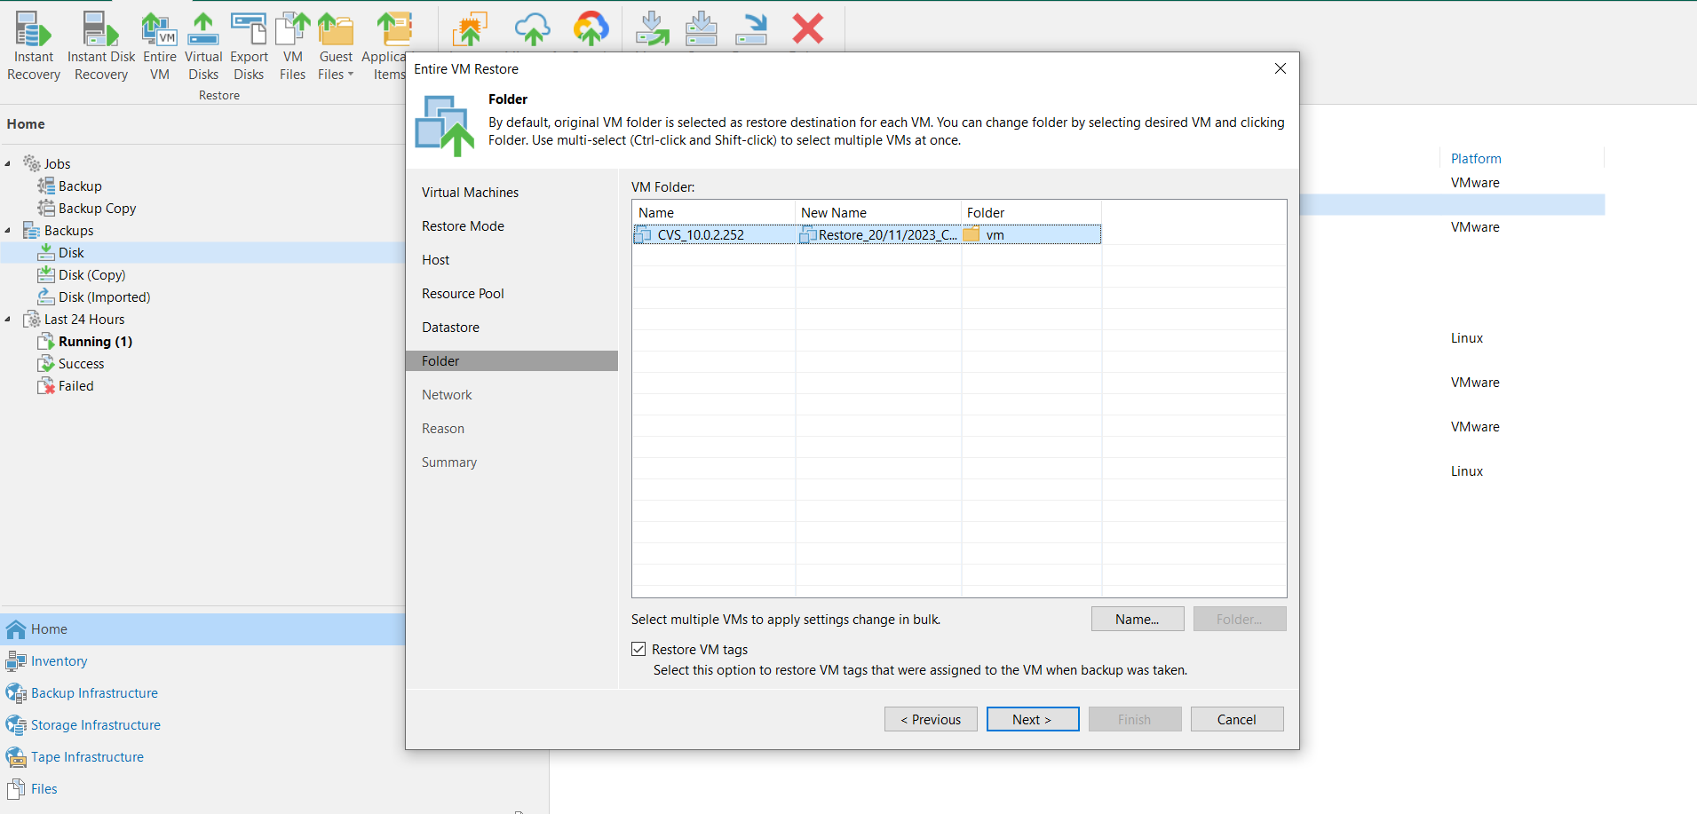

Select 🡪 Next

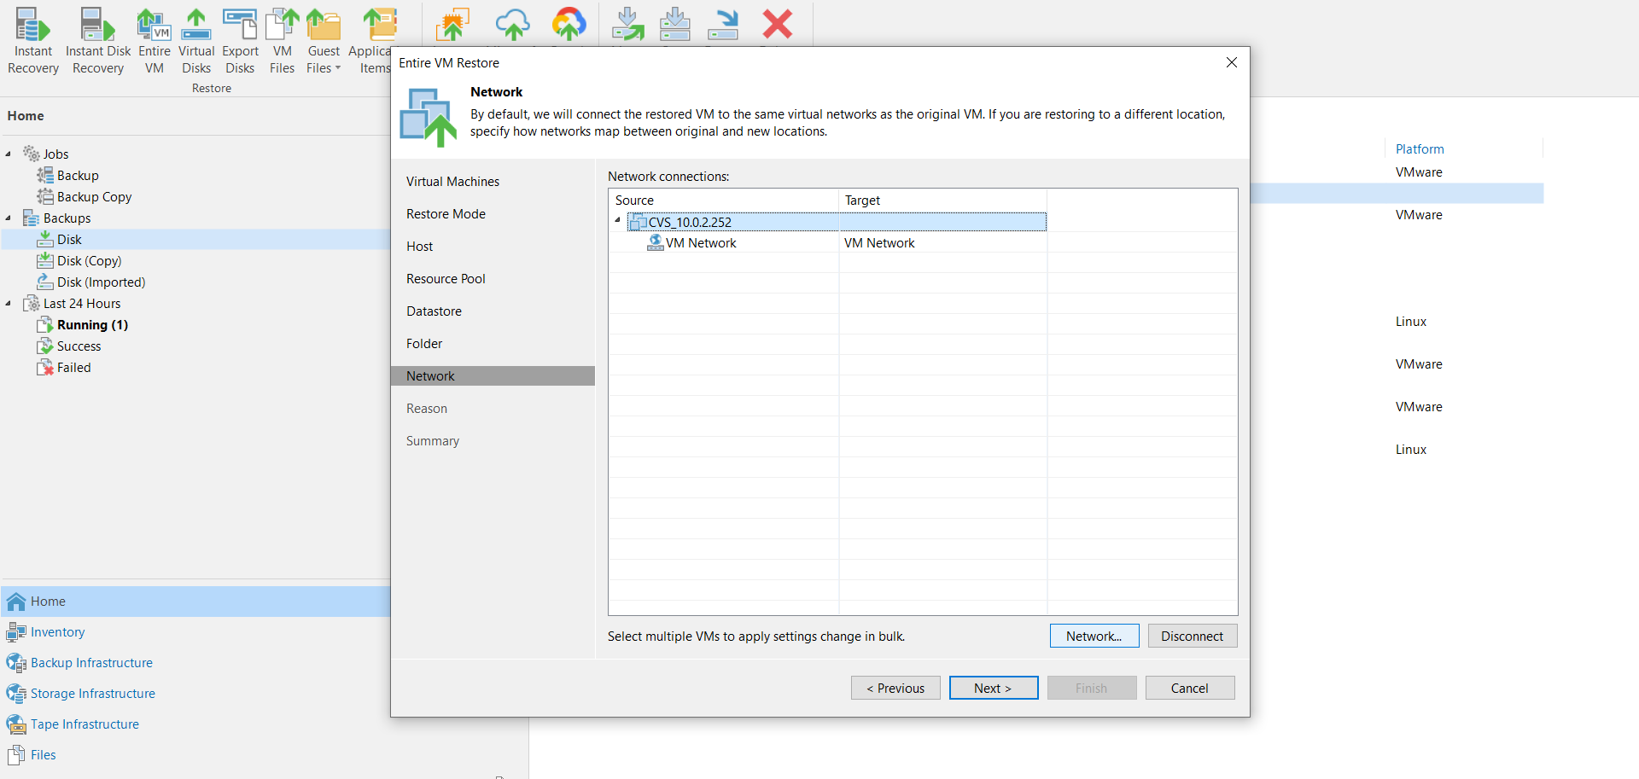

Select the Network , Click 🡪 Next

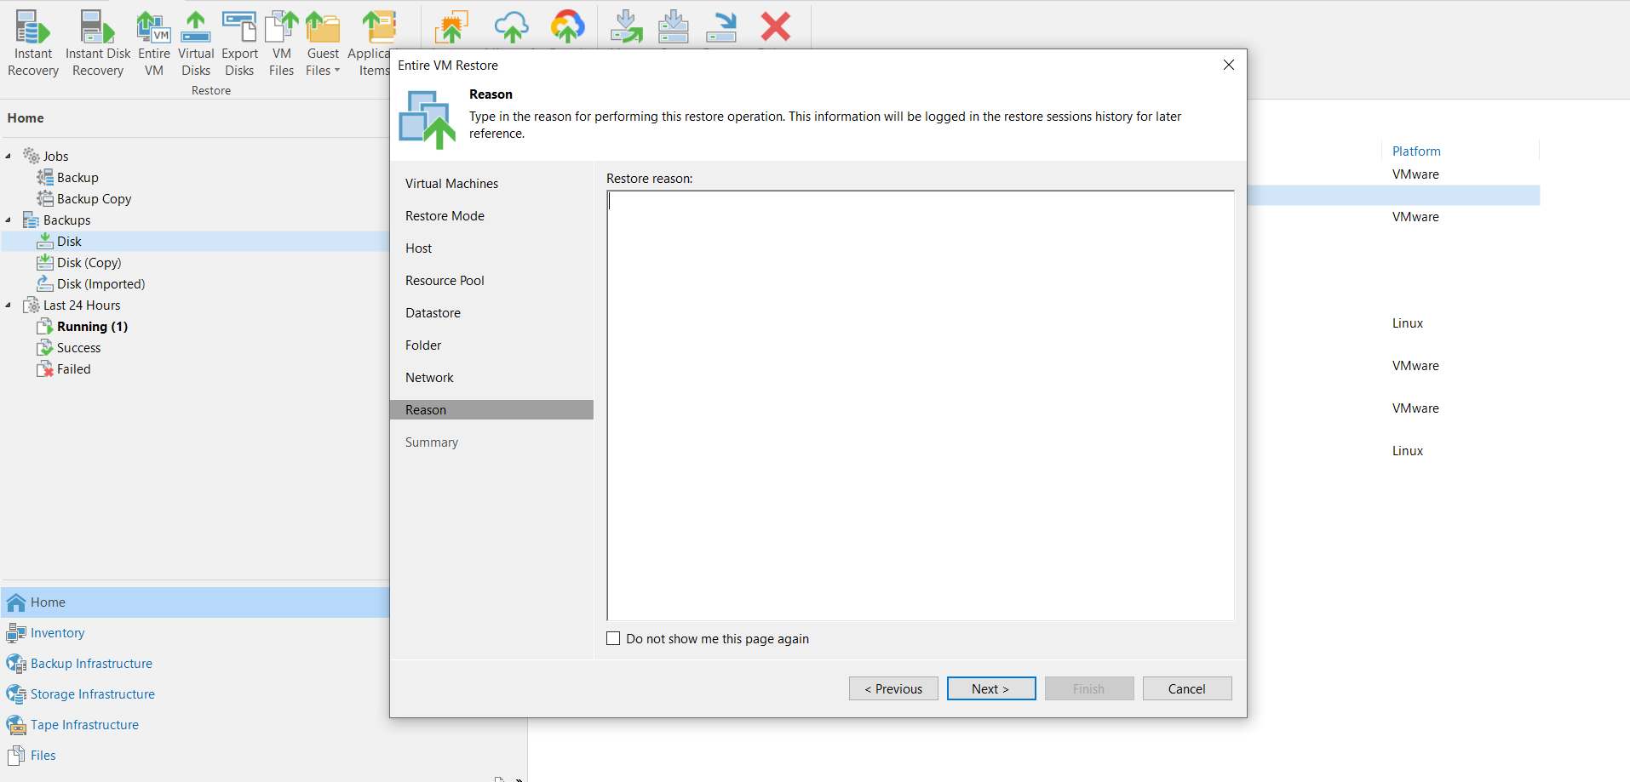

Need to give the Reason for VM creation : Eg : Testing.

Click 🡪 Next

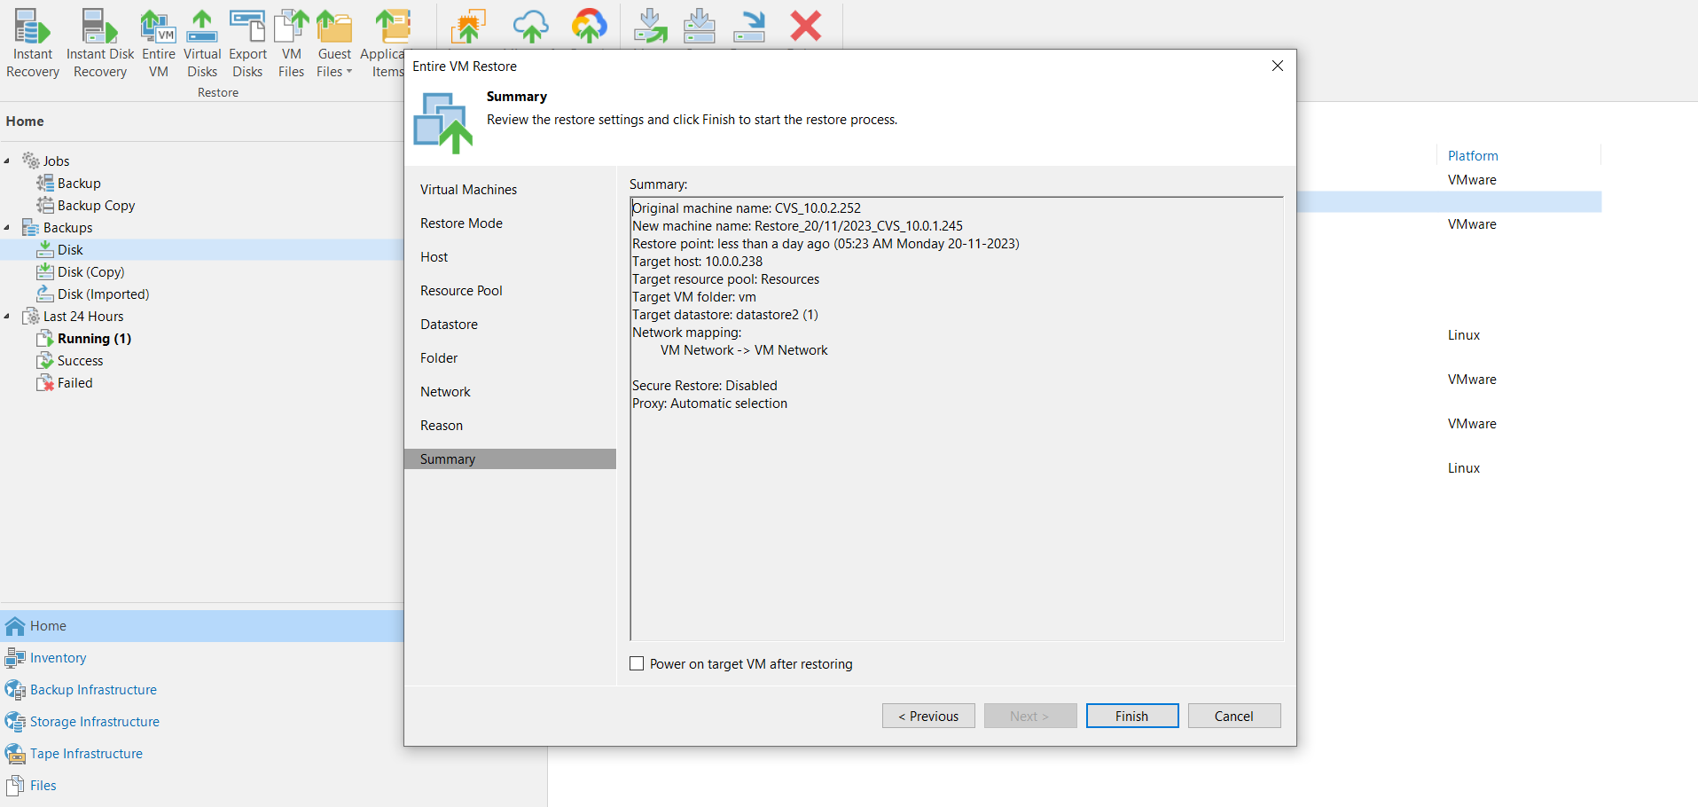

Need to check the information for the configuration settings, Don’t select the Check Box - Uncheck

Click 🡪 Finish.

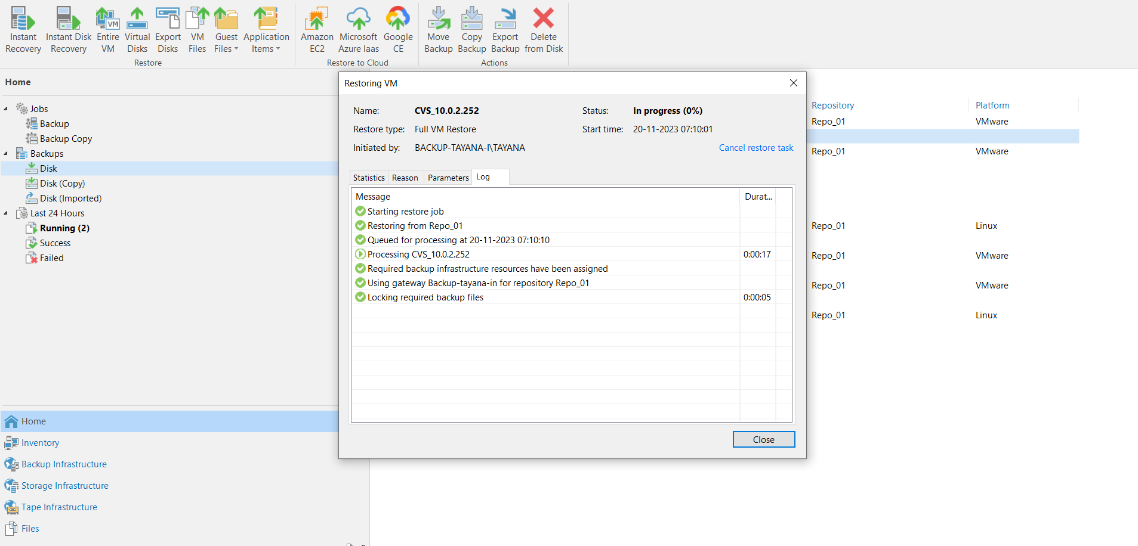

Restoring VM Processing